QUERY OUTPUT

1.

|  |  |  |
| --- | --- | --- |
| LastName | FirstName | Total_Sales |
| Peacock | Margaret | 9635.758 |
| Davolio | Nancy | 5199.593 |
| Leverling | Janet | 4914.343 |
| Fuller | Andrew | 3657.779 |
| Callahan | Laura | 3637.302 |
| Suyama | Michael | 3085.467 |
| Buchanan | Steven | 2294.631 |
| Dodsworth | Anne | 2099.191 |
| King | Robert | 2081.066 |

2.

|  |  |
| --- | --- |
| CustomerName | Total_Spent |
| Ernst Handel | 3640.12 |
| QUICK-Stop | 2160.08 |
| Frankenversand | 1965.11 |
| Save-a-lot Markets | 1946.43 |
| Hungry Owl All-Night Grocers | 1743.02 |

3.

|  |  |
| --- | --- |
| MONTHS | TotalSales |
| 1 | 6221.798 |
| 2 | 2089.784 |

4.

|  |  |  |
| --- | --- | --- |
| EmployeeID | Employee_Name | Avg_Fulfilment_Days |
| 3 | Janet Leverling | 3.84 |
| 8 | Laura Callahan | 3.59 |
| 4 | Margaret Peacock | 3.45 |
| 7 | Robert King | 3.43 |
| 2 | Andrew Fuller | 3.4 |
| 6 | Michael Suyama | 3.33 |
| 9 | Anne Dodsworth | 3.33 |
| 1 | Nancy Davolio | 3.21 |
| 5 | Steven Buchanan | 3 |

5.

|  |  |  |
| --- | --- | --- |
| CustomerName | CITY | TotalSales |
| Seven Seas Imports | London | 1064 |
| Eastern Connection | London | 374 |
| Around the Horn | London | 255 |
| Consolidated Holdings | London | 108 |
| B''s Beverages | London | 75 |
| North/South | London | NULL |

6.

|  |  |  |  |
| --- | --- | --- | --- |
| CustomerName | CustomerID | OrderDate | CustomerOrders |
| Bottom-Dollar Marketse | 10 | 1/10/1997 0:00 | 2 |

7. 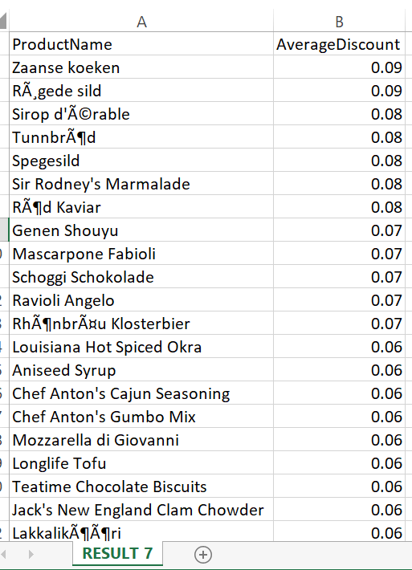

8. 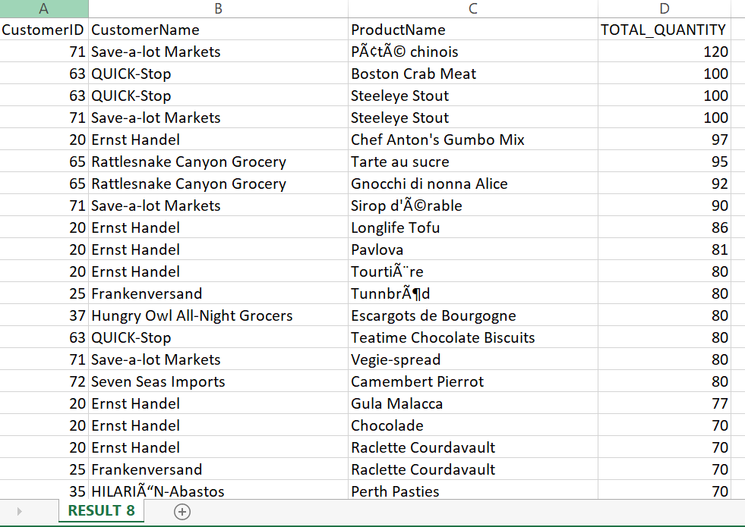

9.

|  |  |  |  |
| --- | --- | --- | --- |
| EmployeeID | Employee_Name | Total_Sales | Employee_Rank |
| 4 | Peacock Margaret | 9165 | 1 |
| 1 | Davolio Nancy | 4932.13 | 2 |
| 3 | Leverling Janet | 4675.58 | 3 |
| 2 | Fuller Andrew | 3489.09 | 4 |
| 8 | Callahan Laura | 3448.23 | 5 |
| 6 | Suyama Michael | 2902.49 | 6 |
| 5 | Buchanan Steven | 2177.74 | 7 |
| 9 | Dodsworth Anne | 2017.97 | 8 |
| 7 | King Robert | 1966.56 | 9 |

10. .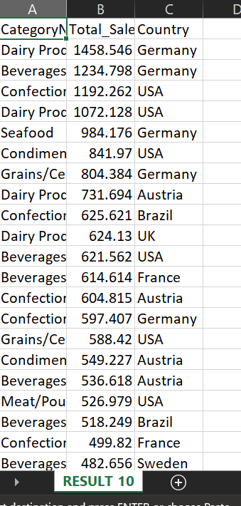

11. 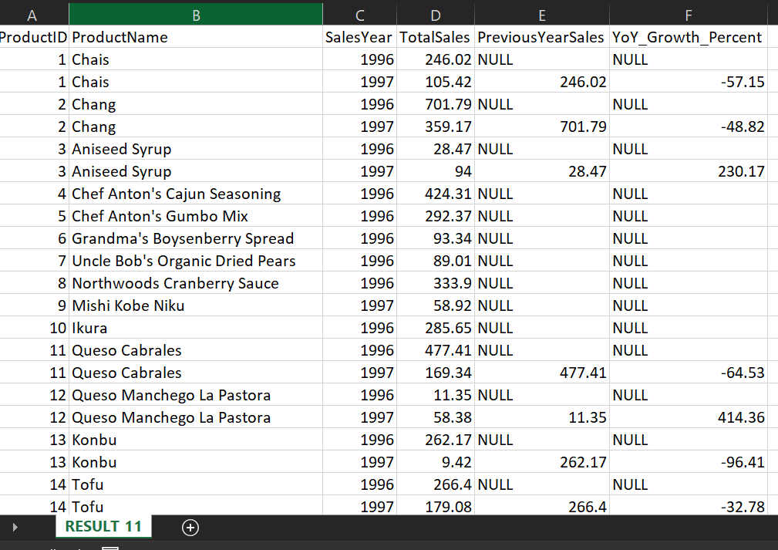

12 .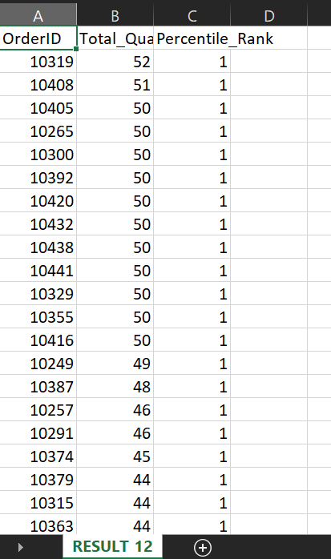

13.

|  |  |  |
| --- | --- | --- |
| ProductID | ProductName | No_ofOrder |
| 9 | Mishi Kobe Niku | 1 |
| 45 | RÃ¸gede sild | 1 |
| 48 | Chocolade | 1 |
| 67 | Laughing Lumberjack Lager | 1 |

14.

|  |  |  |  |
| --- | --- | --- | --- |
| ProductName | CategoryName | Total_Revenue | Revenue_Rank |
| Gorgonzola Telino | Dairy Products | 1206.13 | 1 |
| Pavlova | Confections | 1077.44 | 1 |
| Chang | Beverages | 1060.96 | 1 |
| Gnocchi di nonna Alice | Grains/Cereals | 827.21 | 1 |
| Perth Pasties | Meat/Poultry | 824.92 | 1 |
| Nord-Ost Matjeshering | Seafood | 660.04 | 1 |
| Louisiana Fiery Hot Pepper Sauce | Condiments | 620.85 | 1 |
| Longlife Tofu | Produce | 580.7 | 1 |

15.